**Attachment D – Locality Map**

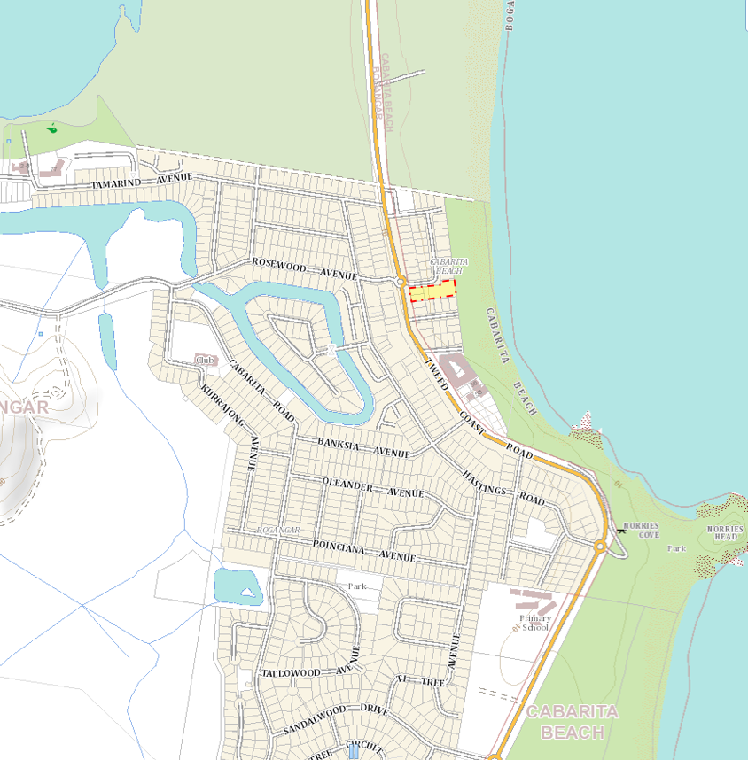

Subject land